Name : Deepanshu Moudgil
Branch : CS
Roll no. : 2400290120091

Github URL : https://github.com/Deepanshu27042005/github-skills-challenge/tree/ci-fix

PR URL : https://github.com/Deepanshu27042005/github-skills-challenge/pull/1

Githib Action Workflow :
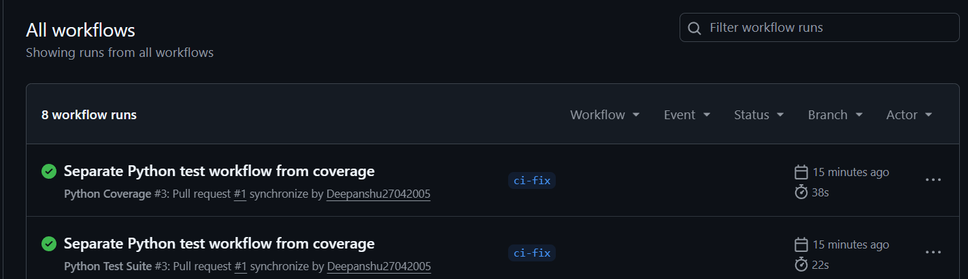

Test Workflow Excecution :

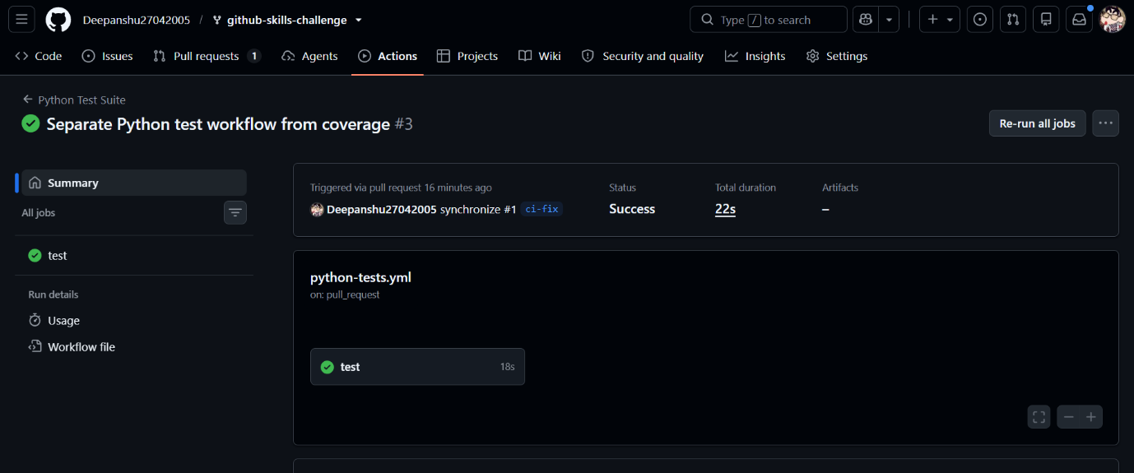
Coverage Workflow :
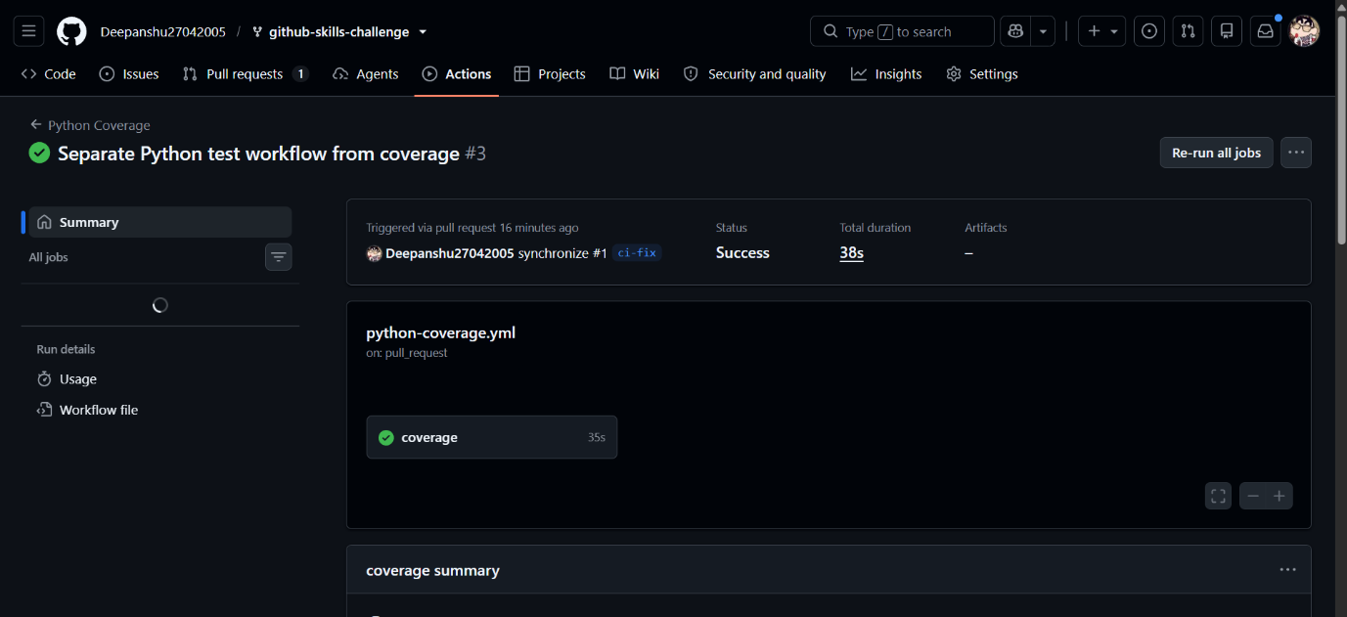

Folder Structure:
